Ex. No: 3 | Flask App Containerization and Docker  Hub Deployment
28-08-2025

Aim
To create a Flask web application, containerize it using Docker, and deploy it to Docker Hub.

Description
- Flask

A lightweight Python web framework.

Used to create web applications, APIs, and services quickly.

Popular because it’s simple, flexible, and doesn’t require heavy setup.

- Docker

A containerization platform.

Packages applications with everything they need (code + libraries + runtime) so they run consistently across different environments.

Solves the “it works on my machine” problem.

- Dockerfile

A blueprint/instruction file that tells Docker how to build an image.

Contains steps like which base image to use, what dependencies to install, and how to start the app.

- Docker Image

A read-only template created from a Dockerfile.

Like a snapshot of your app and environment.

Can be shared, reused, or stored in registries (like Docker Hub).

- Docker Container

A running instance of a Docker image.

Isolated, lightweight, and portable — multiple containers can run on the same machine without interfering.

- Port Mapping

Links a port inside the container to a port on the host machine.

Example: -p 8080:5000 → host’s port 8080 connects to container’s port 5000.

Lets users access services inside a container from outside.

- Docker Hub

A cloud-based registry for storing and sharing Docker images.

Like GitHub for code, but for Docker images.

You can push your images to Docker Hub and pull them on any other machine.

- Tagging

Assigns a version or label to an image.

Example: :latest, :v1.0, etc.

Makes it easy to track and use different versions of an app.

- Push & Pull

Push: Upload your Docker image to a remote registry (like Docker Hub).

Pull: Download an image from a remote registry to your machine.

- Rebuild

Updating your image when your app changes.

Since images are static snapshots, you must rebuild after modifying code to get a fresh version.

Prerequisites

- GitHub account
- Docker Hub account
- Git installed locally
- Python 3.11+
- Docker Desktop (optional for local testing)

Procedure

Step 1: Create the Flask App
app.py

from flask import Flask, render_template_string
app = Flask(__name__)
HTML_TEMPLATE = """
<!DOCTYPE html>
<html lang="en">
<head>
<meta charset="UTF-8">
<title>Flask Docker App</title>
<style>
body {
background: linear-gradient(to right, #00c6ff, #0072ff);
color: white;
font-family: 'Segoe UI', Tahoma, Geneva, Verdana, sans-serif;
text-align: center;
padding-top: 100px;
}

h1 {
font-size: 3em;
margin-bottom: 0.2em;
}
p {
font-size: 1.5em;
}
.card {
background: rgba(255, 255, 255, 0.1);
padding: 2em;
border-radius: 20px;
box-shadow: 0 0 20px rgba(0,0,0,0.3);
width: 50%;
margin: auto;
}
</style>
</head>
<body>
<div class="card">
<h1>🚀 Welcome to Flask + Docker!</h1>
<p>This is a vibrant web page running inside a Docker container.</p>
<p>Change the code → Rebuild → Restart Docker to see updates!</p>
</div>
</body>
</html>
"""
@app.route('/')
def home():
return render_template_string(HTML_TEMPLATE)
if __name__ == '__main__':
app.run(host='0.0.0.0', port=5000)

Step 2: Create requirements.txt
Flask==2.2.5

Step 3: Create Dockerfile
FROM python:3.9-slim
WORKDIR /app

COPY requirements.txt .
RUN pip install -r requirements.txt
COPY . .
EXPOSE 5000
CMD ["python", "app.py"]

Step 4: Build Docker Image
docker build -t flask-docker-app .

Step 5: Run the Container
If port 5000 is free:
docker run -p 5000:5000 flask-docker-app
If port 5000 is occupied:
docker run -p 5050:5000 flask-docker-app
Visit: http://localhost:5050

Step 6: Login to Docker Hub
docker login

Step 7: Tag the Docker Image
docker tag flask-docker-app <your-dockerhub-username>/flask-docker-app:latest

Step 8: Push to Docker Hub
docker push <your-dockerhub-username>/flask-docker-app:latest

Output

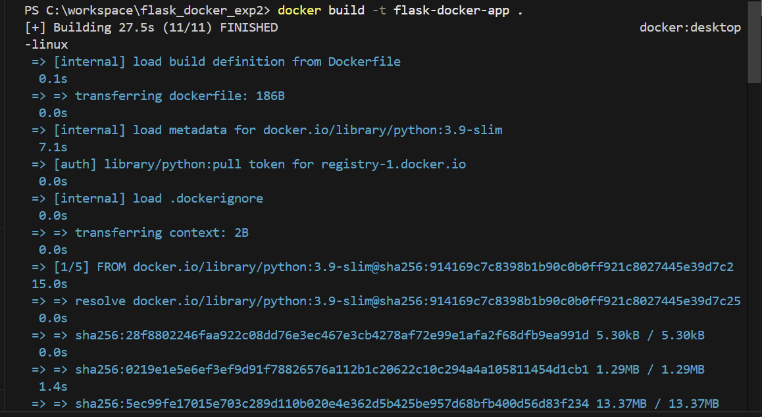

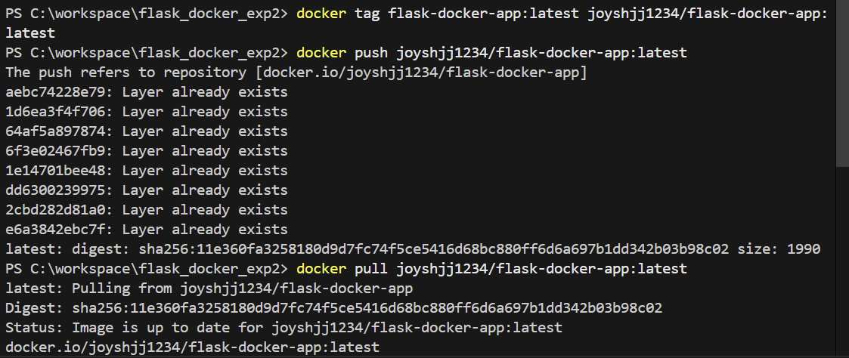

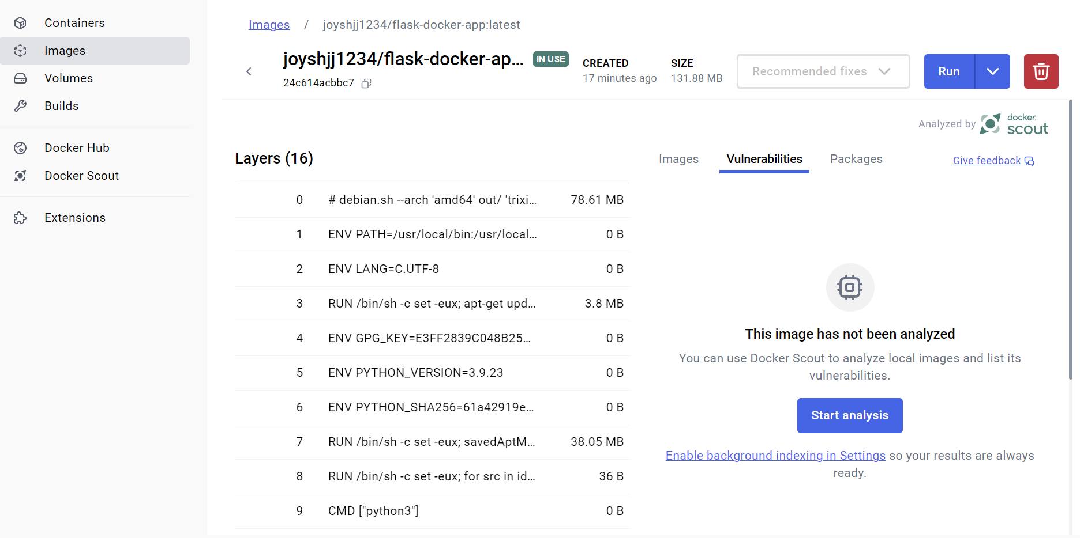

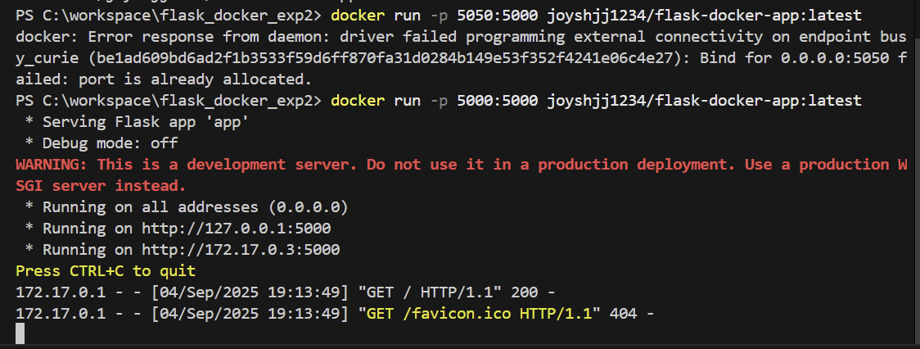

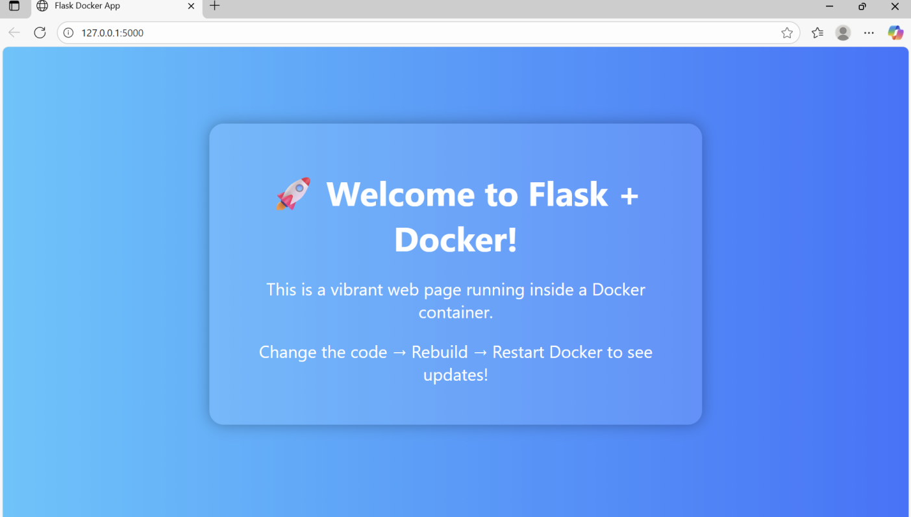

Result
Successfully created a Flask app Docker image, tagged it, and pushed it to Docker Hub for use on any machine.

